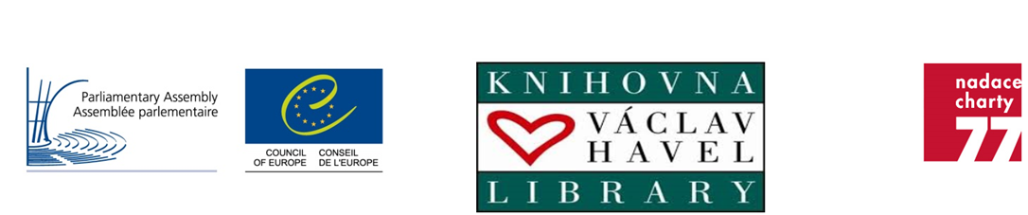

VÁCLAV HAVEL HUMAN RIGHTS PRIZE 2023

NOMINATION FORM

Deadline: 30 June 2023
Please read the regulations and instructions
before completing this form

Instructions

Nominations must be submitted on this form.

Please fill in 1A if the nominee is an individual and 1B if the nominee is an institution or an organisation. All the other rubrics of the form should also be duly completed.

The nomination form (Word format) and the list of signatures of sponsors (PDF format), together with the supporting documents that you may wish to add, must be submitted in English or French and reach the Secretariat at the latest by 30 June 2023.

They should be sent by e-mail, to the following address: hrprize.pace@coe.int

We will confirm receipt of your submission.

1 A. Individual nominee:

Please indicate the name and contact details of the person nominated

Title: [Mr, Mrs, Ms, other…]
Family name:
First name:
Date of birth:
Nationality:
Country of current residence:
Address:
Telephone:
E-mail:
Website/social media (if appropriate):

1 B – Institutions/organisations

Please provide contact and other details of the institution/organisation nominated

Name:
Address:
Telephone:
E-mail:
Website/social media (if appropriate):
Main field of activity:
Country/ies in which it operates:
Year of establishment:
Status (including potential link with
governmental or other authorities,
academia, political parties, etc.):

2. Sponsors:

Please indicate the name and contact details of at least 5 persons / institutions / organisations putting forward the nomination. In order to validate their nomination, the sponsors are asked to sign on the separate list of signatures of sponsors.

Main sponsor:
Title: [Mr, Mrs, Ms, other…]
Family name:
First name:
Profession/occupation:
Capacity in which you know the nominee:
Nationality:
Address:
Telephone:
E-mail:
Website/social media (if appropriate):

Other sponsor:
Title: [Mr, Mrs, Ms, other…]
Family name:
First name:
Profession/occupation:
Capacity in which you know the nominee:
Nationality:
Address:
Telephone:
E-mail:
Website/social media (if appropriate):

Other sponsor:
Title: [Mr, Mrs, Ms, other…]
Family name:
First name:
Profession/occupation:
Capacity in which you know the nominee:
Nationality:
Address:
Telephone:
E-mail:
Website/social media (if appropriate):

Other sponsor:
Title: [Mr, Mrs, Ms, other…]
Family name:
First name:
Profession/occupation:
Capacity in which you know the nominee:
Nationality:
Address:
Telephone:
E-mail:
Website/social media (if appropriate):

Other sponsor:
Title: [Mr, Mrs, Ms, other…]
Family name:
First name:
Profession/occupation:
Capacity in which you know the nominee:
Nationality:
Address:
Telephone:
E-mail:
Website/social media (if appropriate):

3. Description of the nominee’s actions and specific merits in the defence of human rights:

Please explain how the nominee has made an outstanding contribution to the cause of human rights. Indicate whether the nominee’s actions have made a tangible difference for the human rights situation of the target group/country, have been instrumental in uncovering human rights violations, have successfully mobilised public opinion/the international community for a given cause, have been successful in achieving genuine improvements in a given area, have been carried out at a great personal/physical risk, are the result of a specific action or of life-time engagement. Please add any other information you deem relevant.

(maximum one page in Arial 10pt)

4. Supporting documents:

Please insert links to supporting documents (maximum 5).
If the supporting documents are not available on the internet please attach them to the form (electronic version if possible).

5. Date:

